**Homework #8**

GK Posted Feb 2023

**Instructions:**

Your answers should be *direct and explained*. Show your calculations, formulas, logic you follow etc. Explanations do not have to be verbose; they should be just enough for the instructor and/or TA to understand what you are doing. 80% of the grade goes to the explanations and logic you follow and 20% goes to the result. *Correct result with no explanations gets zero points*.

Please respond with your own words and own understanding. Copying the answers without understanding them, defeats the purpose of this homework -- it violates the code of ethics and the integrity of the course.

* *If you are* ***suspected*** *of copying any part of your answers either from a classmate or a web site (without a reference link), you get a zero to the entire homework.*
* *If it is* ***proven*** *that you have copied or plagiarized, you will be reported to your advisor, your sponsor, and the School; serious consequences to your academic record and/or your student status should follow.*
* *This is applicable to both the giving student and the recipient student*.

For the problems/exercises, it is expected to use a spreadsheet (Excel) and/or your own drawing tool (PowerPoint, Visio, Drawsoft, etc) or make a neat drawing by hand. ***You must embed*** these assets into your WORD file with no external references, specifically for Excel. Unless the TA or I click-and-open the object to see your calculations, you will be missing points. *If you do not know how to do so, ask your colleagues, post the question to the Discussion Homework Area, ask our TA and/or ask me.*

Please use font Arial or Calibri of 9pts or 10pts.

DO NOT REMOVE THIS PAGE FROM YOUR SUBMISSION. Also, answer the questions below:

*How long did it take you to complete this homework? _______6________ hours*

*How many hours did you work on your project this week? ____2_______ hours*

Table of Contents

1. NETW-1, 15pts 2

2. NETW-2, 20pts 2

3. Slacks, 5pts 3

4. Midterm, 20pts 3

5. Dates, 20pts 4

6. Gantt, 20pts 4

7. TED, 0pts OPTIONAL 5

## NETW-1, 15pts

You are given the following network.

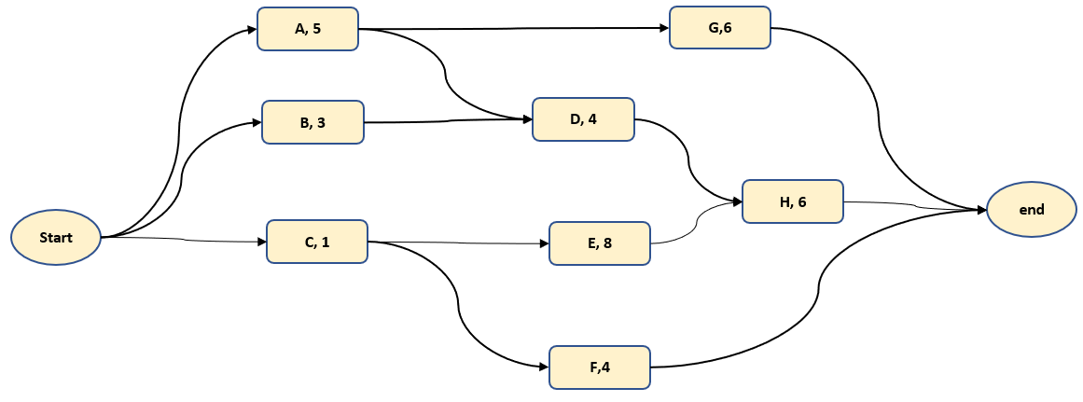

1. (3pt) Solve the network forwards. *Indicate ES, EF on the graph*
2. (8pt) Solve the network backwards. *Indicate LS, LF on the graph*
3. (2pt) Indicate on the graph the Slacks of the tasks in small circles.
4. (2pt) Show on the graph the critical path(s)

*Using a drawing tool is strongly recommended. Handwritten diagrams are acceptable, but they must be very readable and properly annotated.*

*If ES, EF, LS, LF or Slacks are not shown on the graph, you will not get any points to the respective question.*

**Answer:**

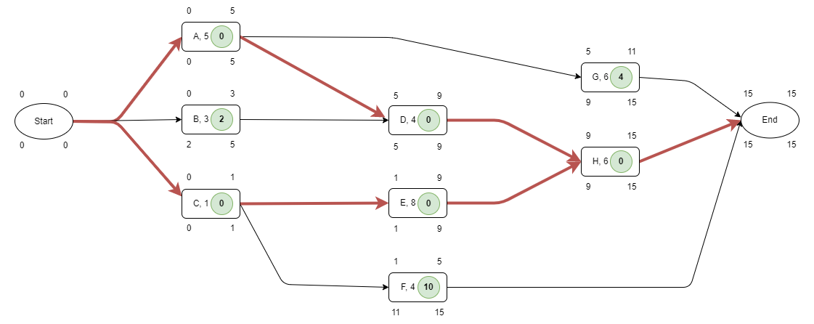

Drawn with draw.io

Slacks are indicated with green circles and Critical paths are indicated with red lines.

## NETW-2, 20pts

You are given the following WBS:

|  |  |  |
| --- | --- | --- |
| TASK | Duration | Predecessor |
| A | 4 |  |
| B | 6 |  |
| C | 8 |  |
| D | 5 | A |
| F | 6 | A, B |
| H | 3 | C |
| G | 7 | B, C |
| I | 4 | F, H |

1. (5pt) Create the AON Network Diagram. *You must draw the graph with the dependencies and include the durations of tasks.*
2. (3pt) Solve this network forwards. *Indicate ES, EF on the graph*
3. (7pt) Solve the network backwards. *Indicate LS, LF on the graph*
4. (3pt) Append in the WBS a column indicating the task-slacks
5. (2pt) Indicate the critical path on the graph

*Hint: You get no points if your responses are not shown clearly on the graph as requested*

**Answer:**

|  |  |  |  |
| --- | --- | --- | --- |
| TASK | Duration | Predecessor | Slack |
| A | 4 |  | 2 |
| B | 6 |  | 0 |
| C | 8 |  | 1 |
| D | 5 | A | 7 |
| F | 6 | A, B | 0 |
| H | 3 | C | 1 |
| G | 7 | B, C | 1 |
| I | 4 | F, H | 0 |

## Slacks, 5pts

Explain the following terms

1. (2p) Define ***Slack of a Task***, i.e. what does “Slack of a Task” indicate? How is it computed?
2. (1p) Define ***Slack of a Path***.
3. (1p) How many non-critical tasks would a critical path contain?
4. (1p) Is it possible one critical task to belong to multiple critical paths?

*You must explain your answers.*

**Answer:**

a. Indicates amount of time a task can be delayed without affecting project completion.

b. Indicates amount of time a set of tasks can be delayed without affecting project completion. Computed as difference between earliest and latest completion times of a path.

c. 0, will not present in a critical path.

d. It is possible for a critical task to belong to multiple critical paths, as long as they have no slacks and share a same critical task.

## Midterm, 20pts

Required Reading: ***Refresh your knowledge in statistics by reviewing Appendix A on Probabilities and Statistics. Then, answer the questions (1) and (2) below.***

***IMPORTANT: You will not be able to answer these questions unless you have comprehended Appendix A***

* Our Spring 2023 EMGT 5220 Class has 22 students, S01…S21. These are the actual grades of the mid-term exam are shown below.

|  |  |  |  |  |  |  |  |  |  |  |  |  |  |  |  |  |  |  |  |  |  |
| --- | --- | --- | --- | --- | --- | --- | --- | --- | --- | --- | --- | --- | --- | --- | --- | --- | --- | --- | --- | --- | --- |
| S01 | S02 | S03 | S04 | S05 | S06 | S07 | S08 | S09 | S10 | S11 | S12 | S13 | S14 | S15 | S16 | S17 | S18 | S19 | S20 | S21 | S22 |
| 69 | 32 | 76 | 62 | 63 | 77 | 88 | 90 | 33 | 67 | 79 | 56 | 25 | 90 | 88 | 83 | 67 | 85 | 87 | 87 | 63 | 82 |

1. (2pts) Compute the ***mean (m)*** using the equation from the Appendix.   
   *You must show the math formula you used in the WORD file.  
   You may not use the Excel formula for average – zero credit if you do.*
2. (2pts) Sort the grades ***(including the student labels S01…S21)*** from the highest grade to the lowest. Draw the chart with x-axis 1…22 and y-axis the descending grades.   
   Compare this with the posted chart in the Common Module.
3. (2pts) Compute the ***median*** using what you learned from the Appendix  
   *You must explain how you found this median in the WORD file.  
   You may not use the Excel formula for median – zero credit if you do.*
4. (4pts) Compute the ***variance (var)*** and the ***standard deviation*** **(stdev)** using the appropriate equation from the Appendix.  *You must show the math formula you used in the WORD file.  
   You may not use the Excel formula for stdev – zero credit if you do.*
5. (5pts) Draw the histogram of the grades using five bins.  
   Compare this with the posted chart in the Common Module.
6. (5pts) Assume that Z=0.9
   * 1. Students with grades above (m+Z*stdev) get an A
     2. Students with grades below (m-Z*stdev) get an F and fail the class
     3. Students between the median and (i) get a B
     4. Students between (ii) and the median get a C

Who are the students getting an A, B, C and F. Mark them on the graph and attach.

*All graphs must be created using Excel. No credit if you do them “by hand”*

**Answer:**

a.

mean is 70.41

b.

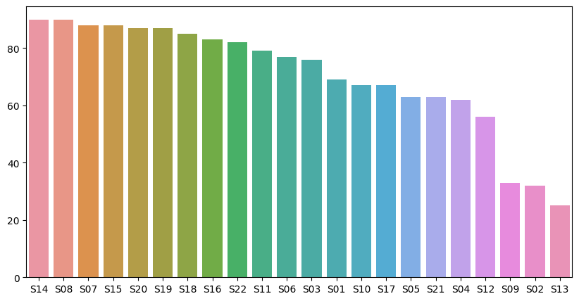

A

B

C

F

c.

median is 76.5

d.

variance is 360.97

standard deviation is 19.00

e.

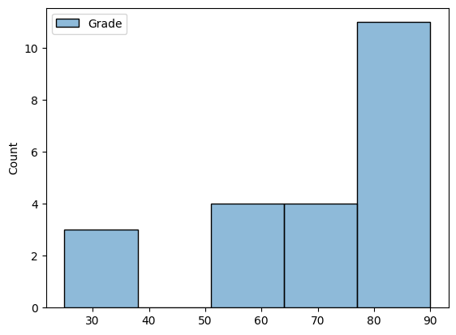

f. marked on the bar plot in part b.

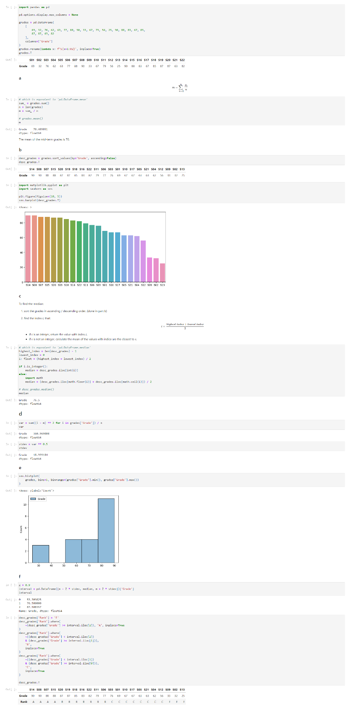



Excel is much more difficult than python, hope this answer is acceptable.

## Dates, 20pts

You are designing a machine using the AON network diagram shown below, starting March 1st, 2023.

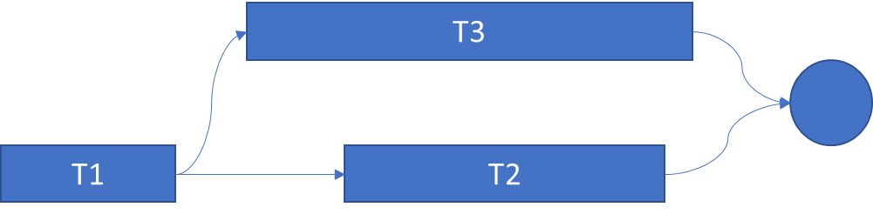

Based on your the WBS, the respective durations are

* T1 is 5-days
* T2 is 7-days
* T3 is 12-days

The “circle” indicates the 1st day the customer will be able to use the machine.

Assume that people work during the weekends, i.e. 7-days per week. Assume also that tasks start at the beginning of the day (i.e. 8:00pm) and finish at the end of the day (i.e. 5:00pm).

1. (8pts) What is the date in March that the customer will be able to use the machine?
2. (2pts) What is the earliest day T2 can start?
3. (2pts) What is the latest date the T2 can finish?
4. (8pts) The team on T2 starts working on March 8th. But this team is slower than your expectations. How many days could they be slower than your expectations of 7-days, but not impacting the delivery to the customer?

*Explain your answers to each question*. *No credit if explanation is not clear or incorrect.*

**Answer:**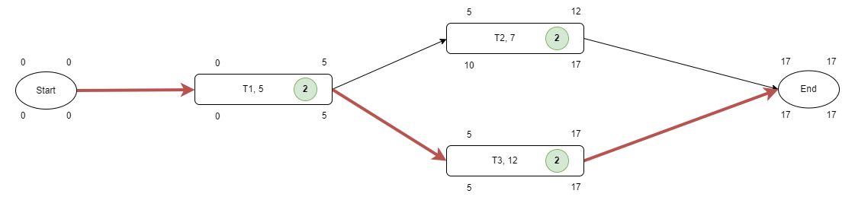

According to the Network Diagram:

a. the customer will be able to use the machine at 5:00 p.m., March 17th.

b. March 5th

c. March 17th

d.

They can be 2 days slower than expectations.

## Gantt, 20pts

You are given the following WBS:

|  |  |  |
| --- | --- | --- |
| TASK | Duration | Predecessor |
| A | 5 |  |
| B | 3 |  |
| C | 1 |  |
| D | 4 | A, B |
| E | 6 | C |
| F | 4 | C |
| G | 6 | A |
| H | 7 | E, D |

Create the Gantt Chart using GanttProject. Use the following guidelines:

* Create two milestones START and END
* Set Project|Properties|Calendar, unclick Sat and Sun so tasks can run during the weekends. Set “New start date”, March 1st, 2023
* Add tasks A…I with the respective durations and predecessors. Make sure that
  + tasks A, B, C have predecessor milestone START
  + END has predecessors F, G, H
* Remove from the left navigation panel the Task Dates and add Task Duration. The left panel should look like:

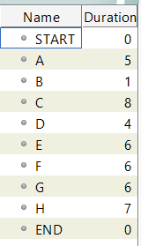

* Save your file in your local machine starting with your first name.

1. (10 pts) Create the Gantt Chart. Cut-and-paste the image of the Gantt Chart here, showing the timeline. Snap (cut and paste the image) here. Ensure that your chart in “nice and readable”  
    *No need to embed your GantChart file.   
   Zero credit if (a) GanttProject was not used, (b) image was not properly included in this file or not readable.*
2. (10 pts) Create the PERT Chart of this. (Click View|PERT). Do the following rearrangements:
   1. Rearrange tasks A, B, C to be vertically positioned in a column after START
   2. Move tasks D, E to the next graphical column
   3. Move task H to the next graphical column between D and E
   4. Move G, H, F to the the next graphical column. G to the top
   5. Confirm that this PERT Chart matches the previous NETW-1 problem. Ensure that your chart in “nice and readable”
   6. Snap a picture of it, i.e. cut and paste the PERT image here.  
      *Zero credit if PERT Chart does not match NETW-1*

CAUTION: if you have rearranged the PERT chart and you flip to the Gantt Chart, your editing/rearrangement work will be lost. In this case, you will have to redo this!

**Answer:**

a.

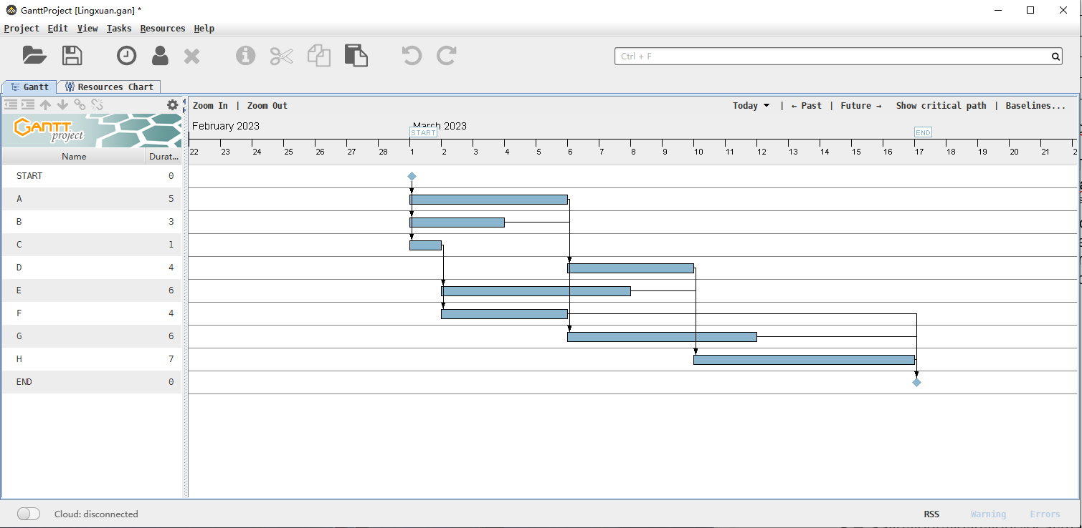

b.

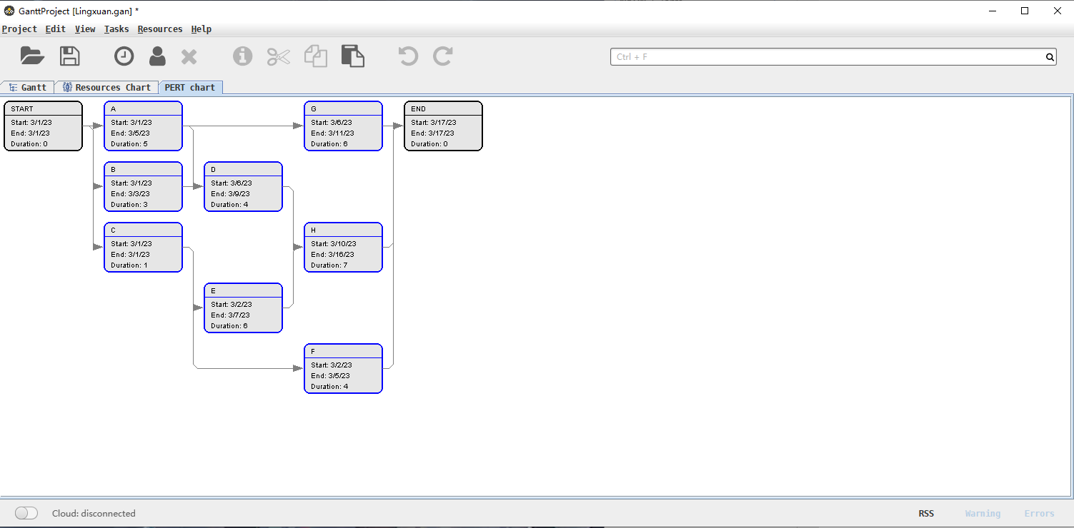

## TED, 0pts OPTIONAL

Watch this TED Talk: [**https://www.ted.com/talks/arthur_benjamin_teach_statistics_before_calculus?language=en**](https://www.ted.com/talks/arthur_benjamin_teach_statistics_before_calculus?language=en)